January 31th, 2016 - Duesseldorf, Germany:
VIA – smart navigation
What’s the best way to bicycle through the city?
A feeling of freedom comes with bicycling. You breathe fresh air and feel the wind blowing through your hair. And above all: you are mobile – whenever and almost wherever you want. This is particularly true in city traffic, where almost all other users of transportation move much less freely than the cyclist – while cars, buses and trucks are caught in rush hour, the cyclist is free from the stop-and-go.
This free and easy feeling is even more present when you have a good knowledge of the city. Or if you have a navigation system for your bike which can give you all the essential information in an easy and intuitive way. Then you can enjoy the ride and always know which way to go.
Only the Most Important Information
The fact is, a lot of bicycle navigation systems flood the rider with information and details. This has led Entwurfreich to the question of how to make life easier and thus better for urban cyclists. A very innovative project was born based on our market analysis: VIA – a bicycle navigation system for the city; and one that displays only the most important information tailored to your needs.
So instead of a split screen map, we chose an arrow which shows the rider in which direction the destination lies. There is only one other screen displayed, showing the relation between the route already covered and the remaining route. All turns are clearly indicated on the left or right of the screen. This minimalist set-up was our basic idea during concept development and leads the user to the destination more quickly, safely and surely.
Route Selection for a More Exciting Cycling Experience
VIA starts as soon as the silicone fastener closes and locks around the handlebar. Riders who simply want to arrive at their destination as quickly as possible – for example when going to work – can select the fastest route. Current construction sites are also taken into consideration here. Those having more time and want to do something more relaxing can choose to take the most scenic route. Cautious cyclists can select the most secure route with the largest number of bicycle paths.
We have synchronized the route profiles to different needs, but they all have one thing in common: maximum simplicity of communication. So even in the city, cyclists can enjoy the freedom which bicycles provide.

Pictures:
ZIP/RAR-archives consist of:

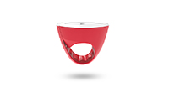 | 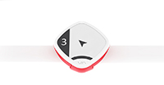 | 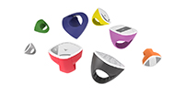
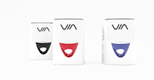 | 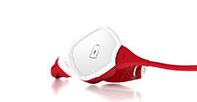 | 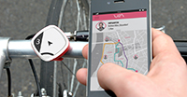

>> 6 High-Res-Pics (300dpi, zip)
>> 6 Web-Pics (72dpi, rar)
>> Entwurfreich Logo (AI, zip)

Caption:
„VIA – smart navigation, Entwurfreich”:

Media contact:

Simon Gorski
ENTWURFREICH GMBH
Fleher Str. 32
40223 Duesseldorf

Phone +49 211 / 15964350
Fax +49 211 / 15964351
media@entwurfreich.com
www.entwurfreich.com

